|  |  |  |
| --- | --- | --- |
| G:\Art, Photos, Logos, Movies, etc\logos\Hyundai_Chrome_Blue_Stacked.jpg | Hyundai Motor America 10550 Talbert Ave., Fountain Valley, CA 92708  TEL: 714-965-3000  MEDIA WEBSITE: HyundaiNews.com  CORPORATE WEBSITE: HyundaiUSA.com | NewsBureauLogo |
|  |  |  |

Contact(s): Derek Joyce Brandon Ramirez

(714) 594-1728 (714) 965-3373

[djoyce@hmausa.com](mailto:djoyce@hmausa.com) [bramirez@hmausa.com](mailto:bramirez@hmausa.com)

**2018 HYUNDAI KONA BREAKS THE MOLD FOR COMPACT SUVS:**

**A CROSSOVER FOR “URBAN ADVENTURERS”**

**New CUV offers Youthful Design, Sporty Driving Character, Leading Safety Technology and Advanced Infotainment Features in an Affordable, Compact Footprint**

**LOS ANGELES, Nov. 29, 2017 –** Today, Hyundai unveiled the U.S.-production version of its convention-shattering Kona crossover at the Los Angeles Auto Show. Kona rides on an all-new CUV platform and is Hyundai’s first B-segment crossover for the U.S. market, appealing to consumers with active lifestyles of all kinds. Kona’s “urban smart armor” exterior styling features voluminous, aggressive body styling complemented by a low and wide stance for great looks and confident handling in a variety of urban and adventure-oriented driving environments. It joins Hyundai’s successful Tucson, Santa Fe and Santa Fe Sport in a full line-up of Hyundai crossovers for the U.S. market. 2018 Kona models will be available at Hyundai dealers in the first quarter of 2018.

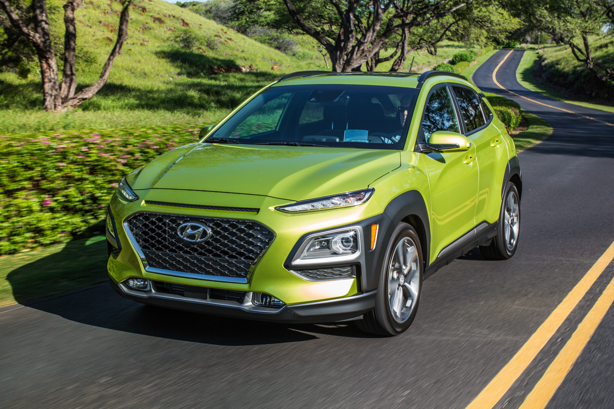

“Our new Kona crossover is a stylish and functional compact CUV, tailored to the needs of customers who pursue active lifestyles of all kinds,” said Mike O’Brien, vice president of Product, Corporate and Digital Planning, Hyundai Motor America. “We’re confident it will set new standards for its segment, with appealing design, cutting-edge connectivity and class-leading available safety features.”

**2018 Kona Highlights**

* Bold, fresh design elements with optional color-contrasting roof and extroverted color options
  + LED headlight, taillight and daytime running light illumination signature
* 2.0-liter Atkinson Cycle 4-cylinder engine with 6-speed automatic transmission
* Standard floating touchscreen with Apple CarPlay™/Android Auto™ capability
* Available 1.6-liter turbocharged, direct-injected engine with 7-speed DCT
* Hyundai Smart Sense (HSS):
  + Forward Collision-Avoidance Assist with Pedestrian Detection
  + Driver Attention Warning
  + Lane Keeping Assist
  + Blind-Spot Collision Warning
  + Rear Cross-Traffic Collision Warning
  + High Beam Assist
* Premium technology availability:
  + 8-inch Navigation System
  + Standard Android Auto™, Apple CarPlay™
  + Next generation Blue Link®
  + Heads-up Display (with active pop-up display screen)
  + Rain-sensing Wipers
  + Wireless device charging

Kona offers a pair of fuel-efficient drivetrains and a stylish, roomy interior. A whole host of advanced safety features are also available including a Lane-Keeping Assist system, Blind-Spot Collision Warning, Rear Cross-Traffic Collision Warning, Lane Change Assist, Parking Distance Warning and Forward Collision-Avoidance Assist with Pedestrian Detection.

**MODERN DESIGN ENHANCED BY LED LIGHTING SIGNATURE**

Kona employs refined aesthetics with sculpted body forms and sporty contours for an athletic, bold, and striking appearance. Its distinctive design is reinforced by the car’s voluminous, aggressive body styling that emphasizes its well-proportioned, dynamic silhouette. A low and wide stance complements its profile, with a long wheelbase and short overhangs, ensuring sporty, nimble handling, in addition to delivering superior driving stability at highway speeds. Its masculine, protective ‘armor’ combines powerfully with the futuristic LED lighting to create a high-tech look.

Kona’s front view conveys a powerful presence, as its armor shows readiness for adventuresome activities. It incorporates Hyundai’s new family identity, the cascading grille, featuring a sporty mesh pattern, flanked by flared, wing-like fenders that dominate the front visage. It’s further enhanced by a separated-headlight design, with high-efficiency LED headlights and LED Daytime Running Lights (DRLs). The visual relationship between the composite lamps, Hyundai's signature cascading grille and unique armor design results in a distinctive crossover character.

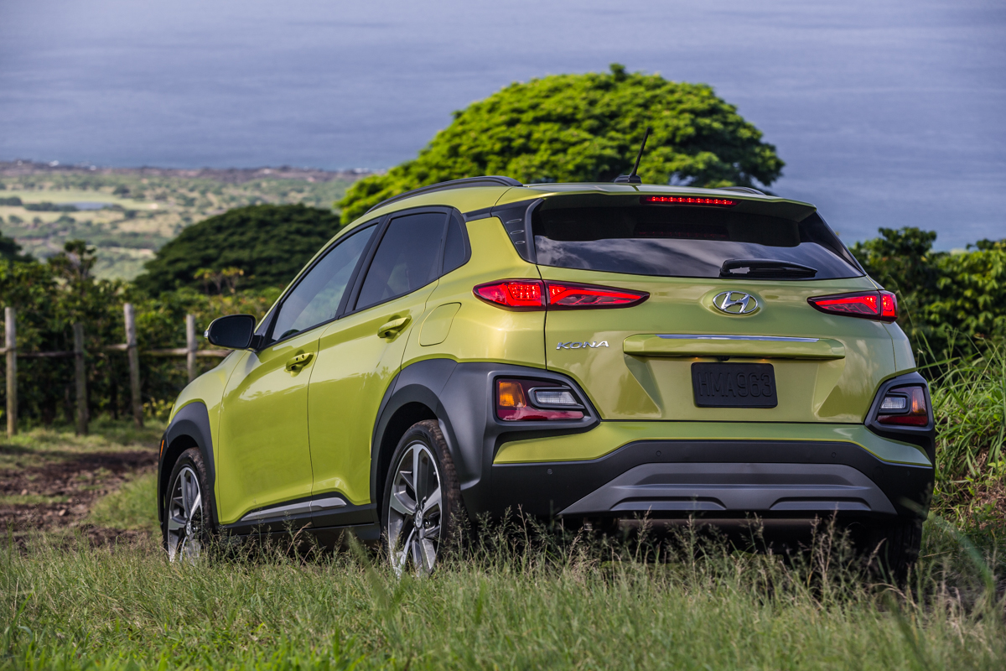

Side-profile design elements reinforce its tough and functional qualities. Contrasting black armor provides a protective skin and visually connects the front to the rear. As with the front LED arrangement, the rear light configuration also creates a truly unique, signature appearance. The slim brake lights, turn indicators and reverse lamps are in a separate configuration, surrounded by protective skin that begins at the C-pillar garnish.

In keeping with its adventuresome demeanor, a number of extroverted color variations allow buyers to further express themselves by choosing colors such as Chalk White, Ultra Black, Sonic Silver, Thunder Gray, Pulse Red, Surf Blue and Lime Twist. The roof is finished with an optional color-contrasting color scheme, providing high contrast between the body and wheels for a distinctive appearance.

**SPACIOUS, COMFORTABLE INTERIOR**

The unique features of the exterior continue inside with a strong horizontal character line creating a wide and spacious feel. Even with its compact dimensions and low roof line, the Kona delivers outstanding interior roominess, especially in front headroom.

The sleek and simple layout interior contrasts with the bold, adventurous exterior design. The audio/navigation display incorporates advanced infotainment features and the standard floating seven-inch touchscreen includes Android Auto™ and Apple CarPlay™ capability. The floating display design adds further to the occupants’ sense of interior openness. Further, HVAC (heating, ventilation and air conditioning) controls are surrounded by soft, fluid details that contribute to a sensuous experience and enhance the comfort-focused environment.

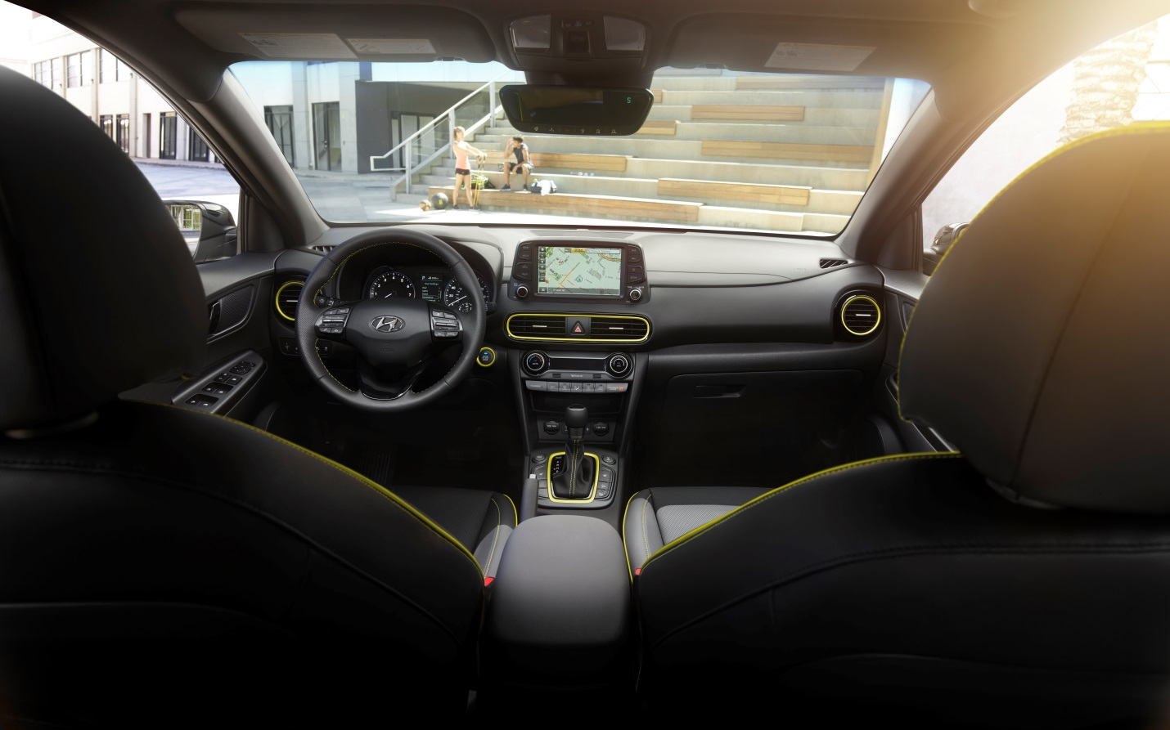

**ALL-NEW CUV PLATFORM**

The all-new Kona compact platform has been developed to provide customers with true CUV capabilities, CUV-level ground clearance and an elevated, command seating position to ensure better visibility and comfort on long journeys, as well as easy ingress and egress. Kona offers occupants generous interior space by optimizing the underfloor layout, including the AWD drivetrain and exhaust system, to reduce central tunnel intrusion on interior space. The optional AWD system and drivetrain is intelligently packaged to offer a spacious interior despite its compact exterior dimensions. Kona also benefits from strategic use of structural adhesives at high stress points on the chassis and extensive use of hot-stamping methods for greater rigidity.

To integrate the optional four-wheel drive system, Hyundai engineers packaged a new intercooler layout and mounting position for the transmission to minimize intrusion into the cabin space. The suspension, fuel, and exhaust components are carefully packaged to maximize rear occupant room. As a result, Kona offers a generous 19.2 cubic feet of rear cargo volume.

The powertrain layout is also designed to create a compact platform capable of incorporating the car’s four-wheel-drive system while maintaining interior space. Suspension component layout is minimized at the rear, allowing for a lower load floor and seating position to deliver impressive headroom and ease of access for rear occupants. Designers also maximized interior space for luggage storage capabilities, reflecting the requirements of customers with active lifestyles. The split-folding rear seats fold flat via a dual-level loading floor that gives three inches of additional vertical space and allows easy access for a variety of recreational equipment.

**POWERFUL AND EFFICIENT POWERTRAINS**

Kona powertrain offerings have top efficiency levels as a primary target. Kona is offered with a choice of two gasoline powertrains. A 2.0-liter 4-cylinder Atkinson engine produces 147 horsepower at 6200 rpm and 132 lb.-ft. of torque at 4500 rpm, paired with a six-speed automatic transmission. The Atkinson cycle design maximizes the effective cylinder expansion ratio (compression stroke vs. power stroke) for greater efficiency. The six-speed automatic offers SHIFTRONIC™ manual-shifting mode and includes an overdrive lock-up torque converter for higher fuel economy at highway speeds. Powertrain NVH has been reduced further through hydraulic transmission mounts.

Limited and Ultimate trims offer the Gamma 1.6-liter 4-cylinder direct-injected, turbocharged engine generating 175 horsepower at 5500 rpm and 195 lb.-ft. of torque from 1500-4500 rpm, an advantage over its key competitors. Peak torque delivery starts at only 1,500 rpm and holds through 4,500 rpm, for low-RPM responsiveness and performance in everyday driving conditions. The turbocharger features low-inertia turbo-spooling response characteristics and an electronic wastegate control for more precise control of manifold pressure. Internally, piston-cooling oil jets ensure cooler piston temperatures for enhanced engine life. The Gamma engine also features a water jacket insert that prioritizes cooling in the upper level of the cylinder block where more combustion heat is generated, resulting in lower cylinder-head temperatures and allowing for leaner air/fuel mixtures for better fuel efficiency.

The turbo engine is coupled to a seven-speed EcoShift® dual-clutch transmission (DCT). This Hyundai-developed dual-clutch transmission offers outstanding efficiency with quick, seamless shifting and brisk acceleration. When compared with some competitors’ continuously-variable transmissions, this DCT is able to handle more torque with minimal power interruption throughout the engine operating range for natural acceleration and premium aural character with greater durability.

**SOPHISTICATED, RESPONSIVE CHASSIS TUNING**

Kona was developed with a focus on enhanced driving dynamics and responsive performance for a variety of urban and multi-surface driving conditions. The long wheelbase, short overhangs and wide track create a planted stance that results in exceptional agility in urban environments with enhanced linear stability and ride comfort. The front suspension features a McPherson strut system using an innovative sub-frame bushing design for enhanced comfort and reduced NVH. The MacPherson strut design uses gas-filled shock absorbers and a hollow stabilizer bar for lower weight and enhanced responsiveness. Available 18-inch alloy wheels with 235/45R18 tires give surefooted, agile handling character on a variety of road surfaces.

Differentiated rear suspension design has been developed for 2WD and AWD models. 2WD models have a rigid torsion beam design for overall stability and control. The AWD drive model uses an independent, dual-arm multi-link design, optimizing ride comfort and stability in the wider ranges of off-road suspension articulation. Its geometry was specially designed for refined body movement on rough roads and off-road terrain. Rear suspension control arm design also minimizes camber and toe changes throughout the wider suspension travel range.

Kona also offers Drive Mode Select, which allows the driver to customize dynamic responses, such as steering feel, transmission and overall powertrain responsiveness to their preferences, and to changing road or traffic conditions. Two differentiated driving modes (Normal and Sport) optimize the torque distribution and shift mapping, tailoring Kona to a variety of driving preferences. In Sport mode, there is a greater emphasis on acceleration with earlier downshifts on braking, while Normal mode slightly prioritizes fuel economy over performance with a more conservative, lower-rpm shift schedule.

**STEERING**

Kona’s motor-driven power steering is more efficient and quieter than traditional hydraulic systems by reducing parasitic losses from ancillary belts and their continual drag on the powertrain. Further, the steering system was engineered and tuned specifically for Kona’s precise and rapid adjustments in steering feel with changing driving conditions. The steering wheel itself offers a wide range of tilt and telescopic adjustment for greater driver comfort.

**SAFETY STRUCTURE**

Hyundai is the only global car manufacturer to produce its own steel for vehicle production for specific benefits to Kona structural integrity and safety. The lightweight unibody structure has been developed with 52 percent Advanced High Strength Steel to deliver leading levels of inherent passive safety characteristics.

Proprietary hot-stamping methods produce lightweight, ultra-strong structural elements to maximize the cabin’s central safety cell. The length of structural adhesives used in Kona production exceeds 375 feet, providing additional torsional rigidity and further reducing overall structure weight for better fuel efficiency, acceleration and handling. The platform also features an innovative multi-load path structure – an advanced energy dispersion technology that boosts impact tolerance by dispersing crash energy across multiple structures to protect passengers in the event of an accident. These design features are expected to give Kona a NHTSA 5-star safety rating as well as an IIHS Top Safety Pick overall.

**ACTIVE SAFETY**

Kona offers advanced active safety features, including Forward Collision-Avoidance Assist (FCA), which uses the car’s front-facing camera and radar to detect an imminent collision and avoid impact or minimize damage by braking autonomously. Three additional systems also utilize the front-view camera to boost safety and convenience: Lane Keeping Assist (LKA), High Beam Assist (HBA), and Driver Attention Warning (DAW).

By sensing road markings, Lane Keeping Assist helps to prevent accidental lane departure by automatically steering the car if required. High Beam Assist automatically controls the high beam headlights depending on surroundings, while the Driver Attention Warning system monitors a spectrum of driver-related characteristics to detect driver fatigue or careless driving.

Kona radar systems also assist with the Blind-Spot Collision Warning (BCW) to detect approaching vehicles that may be obscured from view during highway driving. The Rear Cross-Traffic Collison Warning (RCCW) detects when another vehicle may have entered the car’s rearward path, such as backing out of a parking spot, and provides a driver alert.

**ADVANCED INFOTAINMENT AND CONNECTIVITY**

Kona offers a full suite of sophisticated technologies paired with user-friendly functionality to keep passengers informed and entertained. The premium infotainment system offers various advanced connectivity features, including standard Android Auto™ and Apple CarPlay™, SiriusXM® Radio, HD Radio and next-generation Blue Link® LTE-powered connectivity. The standard seven-inch color LCD display includes AM/FM/MP3 touchscreen audio, auxiliary input jacks, voice-command recognition and Rear View Monitor. The available eight-inch touchscreen navigation display includes next-generation Blue Link, traffic flow and incident data via HD radio, Infinity® premium audio with eight speakers, subwoofer and Clari-Fi ™ music-restoration technology. Smartphone integration is also included in the premium system.

Because some Kona buyers will have downsized from a larger CUV, Kona offers features that they would be accustomed to in larger CUV segments, such as a four-inch color LCD electroluminescent gauge cluster, power driver’s seat, leather heated seats, automatic air conditioning and proximity key. A Heads-Up Display system is available, projecting a virtual image onto the transparent panel mounted behind the instrument panel and helping the driver to keep his or her eyes on the road. With a generous, eight-inch projected-image size and outstanding luminance, the Heads-Up Display ensures both excellent day- and night-time visibility. Information projected includes speed, navigation instructions, Lane Departure Warning and audio system information. Deployed vertically by a simple touch of a button beside the steering wheel, the display disappears into the dashboard when not in use.

In a first for the segment, Kona offers smartphone wireless charging. To charge a device, simply place a compatible smartphone on the wireless-charging interface located in the center console storage, recharging without the need for cables. The system indicates when the phone has fully charged, reminds occupants to remove their phone when exiting the vehicle, and detects when a foreign object is in the recharging area that could interfere with charging. The system is fully compliant with WPC’s Qi standard for ease of use.

**NEXT-GENERATION BLUE LINK® CONNECTED CAR SYSTEM**

Kona Ultimate models are equipped with Blue Link®, including complimentary three-year Blue Link services, with enhanced safety, diagnostic, remote and guidance services. Blue Link brings connectivity directly into the car with technologies like Google Home®, Remote Start with Climate Control, Destination Search powered by Google®, Remote Door Lock/Unlock, Car Finder, Enhanced Roadside Assistance, and Stolen Vehicle Recovery. Blue Link features can be accessed via buttons on the rearview mirror, the MyHyundai.com web portal, the Blue Link smartphone app, Amazon® Alexa Blue Link skill and using the Blue Link Google Assistant app. Some features can also be controlled via Android Wear™ and Apple Watch™ smartwatch apps. The latest release of the Blue Link smartphone app includes:

* Widgets for easy access to remote features
* Access to Blue Link notification settings
* Access to the Hyundai accessories website

More details on specific Blue Link-equipped vehicles available at [www.hyundaibluelink.com](http://www.hyundaibluelink.com/).

**“KONA” NOMENCLATURE**

Kona is named after the idyllic west-coast region of the Big Island of Hawaii. The Kona region is famous among endurance triathletes and thrill-seeking travelers, and this energetic image is further reflected in the innovative and functional design of this lifestyle-focused CUV.

**HYUNDAI MOTOR AMERICA**

Hyundai Motor America, headquartered in Fountain Valley, Calif., is a subsidiary of Hyundai Motor Company of Korea. Hyundai vehicles are distributed throughout the United States by Hyundai Motor America and are sold and serviced through more than 830 dealerships nationwide. All new Hyundai vehicles sold in the U.S. are covered by the Hyundai Assurance program, which includes a 5-year/60,000-mile fully-transferable new vehicle limited warranty, Hyundai’s 10-year/100,000-mile powertrain limited warranty and five years of complimentary Roadside Assistance.

For more details on Hyundai Assurance, please visit [www.HyundaiAssurance.com](http://www.hyundaiassurance.com/)

Please visit our media website at [www.hyundainews.com](http://www.hyundainews.com)

Hyundai Motor America on [Twitter](http://twitter.com/hyundai) | [YouTube](http://www.youtube.com/hyundai) | [Facebook](http://www.facebook.com/Hyundai)